Цель работы: Составить словарь данных для базы данных, которую использует для работы коллектив врачей.

Задачи:

1. Внимательно прочитать задание;
2. Составить словарь данных для базы данных;
3. Выполнить дополнительное задание: составить логическую модель базы данных.

Ход работы:

1. Ознакамливаюсь с заданием:

* В таблицы должны быть занесены имя, пол, дата рождения и домашний адрес каждого их пациента.
* Всякий раз, когда врач осматривает больного, явившегося к нему на прием, или сам приходит к нему на дом, он записывает дату и место, где проводится осмотр, симптомы, диагноз и предписания больному, проставляет имя пациента, а также свое имя.
* Если врач прописывает больному какое-либо лекарство, в таблицу заносится название лекарства, способ его приема, словесное описание предполагаемого действия и возможных побочных эффектов.

1. Составляю словарь данных для базы данных (они отображены в таблицах 1 – 22).
2. Составляю логическую модель базы данных. Рисунок логической модели базы данных представлен ниже на рис. 1.

Таблица №1 - Patients

|  |  |  |  |  |  |  |
| --- | --- | --- | --- | --- | --- | --- |
| **Column** | **Type** | **Null** | **Default** | **Links to** | **Comments** | **MIME** |
| ID_Patient | INT | NOT NULL |  |  |  |  |
| First_Name_Patient | NVARCHAR(20) | NOT NULL |  |  |  |  |
| Middle_Name_Patient | NVARCHAR(20) | NOT NULL |  |  |  |  |
| Last_Name_Patient | NVARCHAR(20) | NOT NULL |  |  |  |  |
| Gender | CHAR(1) | NOT NULL |  |  | Only ‘F’ (female) or ‘M’ (male) |  |
| Birth_Date | DATE | NOT NULL |  |  |  |  |
| Home_Address | NVARCHAR(100) | NOT NULL |  |  |  |  |

Таблица №2 - Индексы таблицы Patient

|  |  |  |  |  |  |  |  |  |
| --- | --- | --- | --- | --- | --- | --- | --- | --- |
| **IndexName** | **Type** | **Unique** | **Packaged** | **Column** | **Unique Elements Amount** | **Comparison** | **Null** | **Comments** |
| PRIMARY | BTREE | YES | NO | ID_Patient | 0 | A | No |  |

Таблица №3 - Visits

|  |  |  |  |  |  |  |
| --- | --- | --- | --- | --- | --- | --- |
| **Column** | **Type** | **Null** | **Default** | **Links to** | **Comments** | **MIME** |
| ID_Visit | INT | NOT NULL |  |  |  |  |
| ID_Doctor | INT | NOT NULL |  | Doctors -> ID_Doctor |  |  |
| ID_Diagnosis | INT | NOT NULL |  | Diagnoses -> ID_Diagnosis |  |  |
| ID_Patient | INT | NOT NULL |  | Patients -> ID_Patient |  |  |
| ID_Place | INT | NOT NULL |  | Place -> ID_Place |  |  |
| Visit_Date | SMALLDATETIME | NOT NULL |  |  |  |  |

Таблица №4 - Индексы таблицы Visits

|  |  |  |  |  |  |  |  |  |
| --- | --- | --- | --- | --- | --- | --- | --- | --- |
| **IndexName** | **Type** | **Unique** | **Packaged** | **Column** | **Unique Elements Amount** | **Comparison** | **Null** | **Comments** |
| PRIMARY | BTREE | YES | NO | ID_Visit | 0 | A | No |  |
| FOREIGN | BTREE | NO | NO | ID_Doctor | 0 | A | No |  |
| FOREIGN | BTREE | NO | NO | ID_Diagnosis | 0 | A | No |  |
| FOREIGN | BTREE | NO | NO | ID_Patient | 0 | A | No |  |
| FOREIGN | BTREE | NO | NO | ID_Place | 0 | A | No |  |

Таблица №5 - Doctors

|  |  |  |  |  |  |  |
| --- | --- | --- | --- | --- | --- | --- |
| **Column** | **Type** | **Null** | **Default** | **Links to** | **Comments** | **MIME** |
| ID_Doctor | INT | NOT NULL |  |  |  |  |
| First_Name_Doctor | NVARCHAR(20) | NOT NULL |  |  |  |  |
| Middle_Name_Doctor | NVARCHAR(20) | NOT NULL |  |  |  |  |
| Last_Name_Doctor | NVARCHAR(20) | NOT NULL |  |  |  |  |

Продолжение таблицы №5 – Doctors

|  |  |  |  |  |  |  |
| --- | --- | --- | --- | --- | --- | --- |
| Gender | CHAR(1) | NOT NULL |  |  | Only ‘F’ (female) or ‘M’ (male) |  |

Таблица №6 - Индексы таблицы Doctors

|  |  |  |  |  |  |  |  |  |
| --- | --- | --- | --- | --- | --- | --- | --- | --- |
| **IndexName** | **Type** | **Unique** | **Packaged** | **Column** | **Unique Elements Amount** | **Comparison** | **Null** | **Comments** |
| PRIMARY | BTREE | YES | NO | ID_Doctor | 0 | A | No |  |

Таблица №7 - Symptoms

|  |  |  |  |  |  |  |
| --- | --- | --- | --- | --- | --- | --- |
| **Column** | **Type** | **Null** | **Default** | **Links to** | **Comments** | **MIME** |
| ID_Symptom | INT | NOT NULL |  |  |  |  |
| Symptoms_Name | NVARCHAR(100) | NOT NULL |  |  |  |  |

Таблица №8 - Индексы таблицы Symptoms

|  |  |  |  |  |  |  |  |  |
| --- | --- | --- | --- | --- | --- | --- | --- | --- |
| **IndexName** | **Type** | **Unique** | **Packaged** | **Column** | **Unique Elements Amount** | **Comparison** | **Null** | **Comments** |
| PRIMARY | BTREE | YES | NO | ID_Symptom | 0 | A | No |  |

Таблица №9 - Symptoms_Visit

|  |  |  |  |  |  |  |
| --- | --- | --- | --- | --- | --- | --- |
| **Column** | **Type** | **Null** | **Default** | **Links to** | **Comments** | **MIME** |
| ID_Symptom | INT | NOT NULL |  | Symptoms -> ID_Symptom |  |  |
| ID_Visit | INT | NOT NULL |  | Visit -> ID_Visit |  |  |

Таблица №10 - Индексы таблицы Symptoms_Visit

|  |  |  |  |  |  |  |  |  |
| --- | --- | --- | --- | --- | --- | --- | --- | --- |
| **IndexName** | **Type** | **Unique** | **Packaged** | **Column** | **Unique Elements Amount** | **Comparison** | **Null** | **Comments** |
| PRIMARY | BTREE | YES | NO | ID_Symptom | 0 | A | No |  |
| PRIMARY | BTREE | YES | NO | ID_Visit | 0 | A | No |  |

Продолжение таблица №10 – Индексы таблицы Symptoms_Visit

|  |  |  |  |  |  |  |  |  |
| --- | --- | --- | --- | --- | --- | --- | --- | --- |
| FOREIGN | BTREE | NO | NO | ID_Symptom | 0 | A | No |  |
| FOREIGN | BTREE | NO | NO | ID_Visit | 0 | A | No |  |

Таблица №11 - Diagnoses

|  |  |  |  |  |  |  |
| --- | --- | --- | --- | --- | --- | --- |
| **Column** | **Type** | **Null** | **Default** | **Links to** | **Comments** | **MIME** |
| ID_Diagnosis | INT | NOT NULL |  |  |  |  |
| Diagnosis_Name | NVARCHAR(100) | NOT NULL |  |  |  |  |

Таблица №12 - Индексы таблицы Diagnoses

|  |  |  |  |  |  |  |  |  |
| --- | --- | --- | --- | --- | --- | --- | --- | --- |
| **IndexName** | **Type** | **Unique** | **Packaged** | **Column** | **Unique Elements Amount** | **Comparison** | **Null** | **Comments** |
| PRIMARY | BTREE | YES | NO | ID_Diagnosis | 0 | A | No |  |

Таблица №13 - Side_Effect

|  |  |  |  |  |  |  |
| --- | --- | --- | --- | --- | --- | --- |
| **Column** | **Type** | **Null** | **Default** | **Links to** | **Comments** | **MIME** |
| ID_SideEffect | INT | NOT NULL |  |  |  |  |
| Name_SideEffect | NVARCHAR(60) | NOT NULL |  |  |  |  |

Таблица №14 - Индексы таблицы Side_Effect

|  |  |  |  |  |  |  |  |  |
| --- | --- | --- | --- | --- | --- | --- | --- | --- |
| **IndexName** | **Type** | **Unique** | **Packaged** | **Column** | **Unique Elements Amount** | **Comparison** | **Null** | **Comments** |
| PRIMARY | BTREE | YES | NO | ID_SideEffect | 0 | A | No |  |

Таблица №15 - Medicine_Visit

|  |  |  |  |  |  |  |
| --- | --- | --- | --- | --- | --- | --- |
| **Column** | **Type** | **Null** | **Default** | **Links to** | **Comments** | **MIME** |
| ID_Visit | INT | NOT NULL |  | Visits -> ID_Visit |  |  |
| ID_Medicine | INT | NOT NULL |  | Medicine -> ID_Medicine |  |  |

Таблица №16 - Индексы таблицы Medicine_Visit

|  |  |  |  |  |  |  |  |  |
| --- | --- | --- | --- | --- | --- | --- | --- | --- |
| **IndexName** | **Type** | **Unique** | **Packaged** | **Column** | **Unique Elements Amount** | **Comparison** | **Null** | **Comments** |
| PRIMARY | BTREE | YES | NO | ID_Visit | 0 | A | No |  |
| PRIMARY | BTREE | YES | NO | ID_Medicine | 0 | A | No |  |

Продолжение таблицы №16 – Индексы таблицы Medicine_Visit

|  |  |  |  |  |  |  |  |  |
| --- | --- | --- | --- | --- | --- | --- | --- | --- |
| FOREIGN | BTREE | NO | NO | ID_Visit | 0 | A | No |  |
| FOREIGN | BTREE | NO | NO | ID_Medicine | 0 | A | No |  |

Таблица №17 - Medicine

|  |  |  |  |  |  |  |
| --- | --- | --- | --- | --- | --- | --- |
| **Column** | **Type** | **Null** | **Default** | **Links to** | **Comments** | **MIME** |
| ID_Medicine | INT | NOT NULL |  |  |  |  |
| Medicine_Name | NVARCHAR(60) | NOT NULL |  |  |  |  |
| ID_HowToUse | INT | NOT NULL |  | HowToUse -> ID_HowToUse |  |  |
| Description | NVARCHAR(350) | NOT NULL |  |  |  |  |
| ID_SideEffect | INT | NOT NULL |  | Side_Effect -> ID_SideEffect |  |  |

Таблица №18 - Индексы таблицы Medicine

|  |  |  |  |  |  |  |  |  |
| --- | --- | --- | --- | --- | --- | --- | --- | --- |
| **IndexName** | **Type** | **Unique** | **Packaged** | **Column** | **Unique Elements Amount** | **Comparison** | **Null** | **Comments** |
| PRIMARY | BTREE | YES | NO | ID_Medicine | 0 | A | No |  |

Продолжение таблицы №18 – Индексы таблицы Medicine

|  |  |  |  |  |  |  |  |  |
| --- | --- | --- | --- | --- | --- | --- | --- | --- |
| FOREIGN | BTREE | NO | NO | ID_HowToUse | 0 | A | NO |  |
| FOREIGN | BTREE | NO | NO | ID_SideEffect | 0 | A | NO |  |

Таблица №19 - Place

|  |  |  |  |  |  |  |
| --- | --- | --- | --- | --- | --- | --- |
| **Column** | **Type** | **Null** | **Default** | **Links to** | **Comments** | **MIME** |
| ID_Place | INT | NOT NULL |  |  |  |  |
| Address | NVARCHAR(100) | NOT NULL |  |  |  |  |

Таблица №20 - Индексы таблицы Place

|  |  |  |  |  |  |  |  |  |
| --- | --- | --- | --- | --- | --- | --- | --- | --- |
| **IndexName** | **Type** | **Unique** | **Packaged** | **Column** | **Unique Elements Amount** | **Comparison** | **Null** | **Comments** |
| PRIMARY | BTREE | YES | NO | ID_Place | 0 | A | No |  |

Таблица №21 - HowToUse

|  |  |  |  |  |  |  |
| --- | --- | --- | --- | --- | --- | --- |
| **Column** | **Type** | **Null** | **Default** | **Links to** | **Comments** | **MIME** |
| ID_HowToUse | INT | NOT NULL |  |  |  |  |
| How_To_Use | NVARCHAR(350) | NOT NULL |  |  |  |  |

Таблица №22 - Индексы таблицы HowToUse

|  |  |  |  |  |  |  |  |  |
| --- | --- | --- | --- | --- | --- | --- | --- | --- |
| **IndexName** | **Type** | **Unique** | **Packaged** | **Column** | **Unique Elements Amount** | **Comparison** | **Null** | **Comments** |
| PRIMARY | BTREE | YES | NO | ID_HowToUse | 0 | A | No |  |

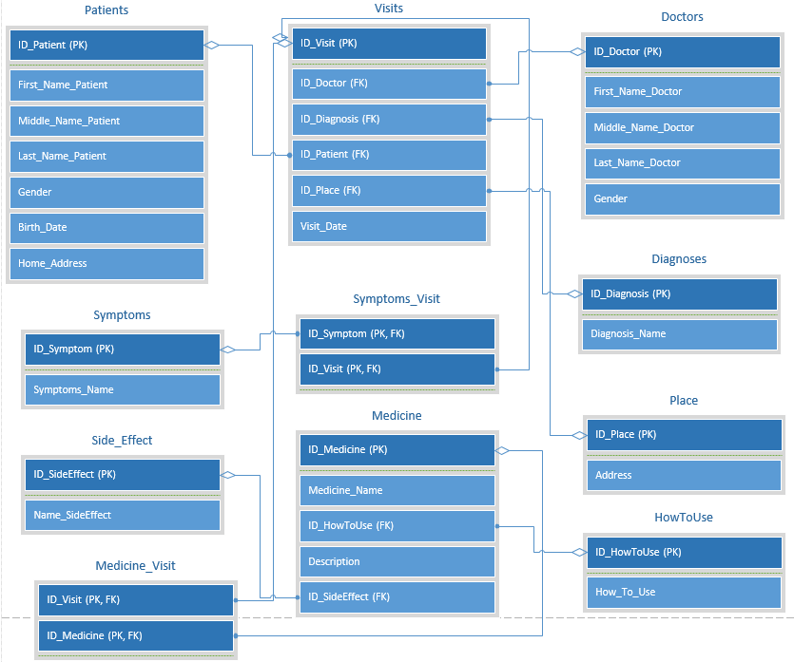

Рис 1. Логическая модель базы данных

Вывод: Я составил словарь данных для базы данных, которую использует для работы коллектив врачей.